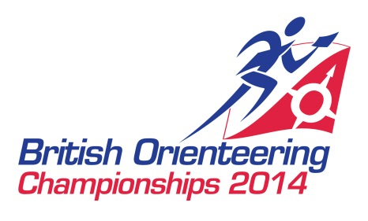

**PRESS RELEASE**

**Thousands to Navigate to the North East**

On the 31st May thousands of people are set to navigate to the heart of Northumberland as the local area hosts the British Orienteering Championships. The event, hosted by British Orienteering in conjunction with the North East Orienteering Association will attract the UKs top orienteers as they aim to become the 2014 British Champion.

The event will take place over 2 days, with a long distance event being held on the 31st May in Thrunton Woods and Callaly. The long distance event will test the athletes navigation and fitness skills as they aim to navigate for up to 15km across the picturesque Northumberland terrain.

Former Great Britain athlete Pippa Archer who lives in Durham says, “I love orienteering in Northumberland - the unspoilt scenery plays host to some fantastic orienteering terrain. Adaption will be the name of the game at BOC this year as you race through open moorland, natural woodland, and plantation forest, taking on tricky contour details and exciting rock features! Orienteering up here often feels like a journey of discovery - come and join me in exploring this beautiful corner of England.”

On Sunday 1st June a relay race for clubs from across the country will take place on the Cragg Estate and Chesterhope Common. This is an opportunity for teams of all ages to compete against each other to find worthy British Champions.

Orienteering is a navigation and running sport that tests both the mind and the body. It is suitable for all ages with competitors aged 8 to 80 taking part in the event. As a sport, orienteering is unique in its ability to cater for all family members with participants from across the generations.

Sally Pygott from British Orienteering said, “By working with the local council and businesses we hope to generate a real boost to the local economy as many of the competitors take the opportunity to explore the area and extend their stay beyond the competition weekend. We welcome spectators at the event and we will be providing taster courses so that local people can try the sport for themselves. As a beginner you need no navigation experience and we have courses to suit all fitness levels.”

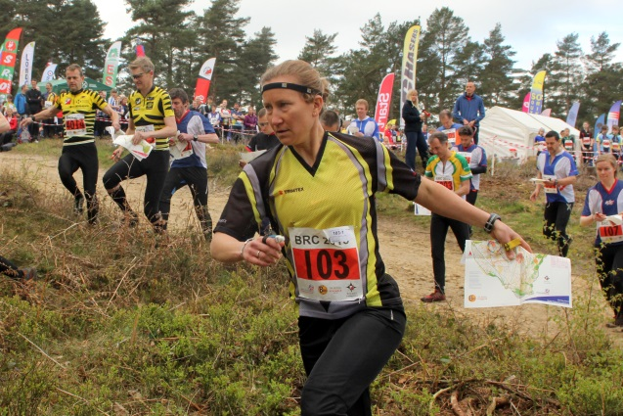For further information about the event please visit the event website. [www.boc2014.org.uk](http://www.boc2014.org.uk)

For further information about the sport of orienteering please visit [www.britishorienteering.org.uk](http://www.britishorienteering.org.uk)

Pictured: Competitors taking part in the 2013 British Relay Championships.